
gf
Touchstones Project REACH
(Religious Education Arts Clearing House)

Lifespan RE Resources for Ritual

Introduction
This packet explores the theme of Ritual, which builds in different ways on the November theme of Remembrance and the April theme of Grief.

Ritual draws on our first source. It expresses the origin of ritual as a “direct experience of transcending mystery and wonder” and the goal of ritual as “a renewal of the spirit and an openness to the forces which create and uphold life.” Importantly, our sixth source, drawing on the wisdom of indigenous peoples, invites us to “celebrate the sacred circle of life and …live in harmony with the rhythms of nature.” Our most distinctive rituals, lighting the chalice, Water Communion, and Flower Communion, draw on these two sources.

Ritual marks time, structures time, and gives time meaning. An interesting perspective on ritual is provided by Renee Garfinkel in Why We Cry for Ritual (see https://www.psychologytoday.com/us/blog/time-out/202303/why-we-cry-for-ritual)

In thinking about ritual, it is important to distinguish among habits, routines, and rituals, especially in the context of personal rituals. Anne-Laure Le Cunff writes, “Both habits and routines are regular and repeated actions, but habits happen with little or no conscious thought [i.e., ‘nearly or completely involuntary’], whereas routines require a higher degree of intention and effort.” Furthermore, habits tend to form around simple actions, while routines are more complex. Like routines, rituals involve intention and effort but are charged with individual and/or collective meaning.

Children experience habits, routines, and rituals beyond the home. Habit: washing one’s hands after using the bathroom. Routine: Getting in a line in a classroom to go to recess. Ritual: Pledge of allegiance.

Habits, routines, and rituals are essential for children and youth. Family rituals give children security while shaping the identity of the family and the child. In a family setting, rituals confer belonging. See 25 Family Rituals That Foster Connection at https://www.mindfullittleminds.com/25-family-rituals-that-foster-connection/ and 41 Family Rituals That Teach Responsibility, Kindness, and Compassion by Ashley Cullins at https://biglifejournal.com/blogs/blog/family-rituals-teaching-responsibility-positivity-kindness-compassion

Going to church is a routine, while lighting a chalice is a ritual. A sub-set of rituals are rites of passage. Another sub-set involves how holidays and holy days are observed, generally, by a culture or society and, specifically, by a family. In June, the following holidays can be a focus of discussion
- Father’s Day, June 18
- Juneteenth, June 19 (United States)
- Summer Solstice, June 21
- National Indigenousness Peoples Day, June 21 (Canada)
- Pride Day, June 25 (United States), June 18 (International), Various dates in Canda by province and city

Resources for Children
1.0: Pins
2.0: Wisdom Stories
The Tapestry of Faith stories are not listed since those are easily accessible in the curricula listed at 4.0 & 5.0
2.1: This Must be Sufficient by Elie Wiesel (237 words)
3.0: Children’s Books
Family Rituals
3.1: Our Table by Peter H. Reynolds (Author, Illustrator) 2021

Holidays & Holy Days

3.2: Let’s Celebrate!: Special Days Around the World by Kate DePalma (Author) and Martina Peluso (Illustrator) (2019)

3.3: Our Favorite Day of the Year by A. E. Ali (Author) and Rahele Jomepour Bell (Illustrator) (2020)

3.4: Giving Thanks Around the World by Christine Wolf (2007)

3.5: The Nian Monster by Andrea Wang (Author), Alina Chau (Illustrator) (2016)

Pagan Holidays and Rituals

3.6: Rupert’s Tales: The Wheel of the Year Beltane, Litha, Lammas, and Mabon by Kyrja (Author) and Tonia Bennington Osborn (Illustrator) (2011)
3.7: Rupert’s Tales: The Wheel of the Year - Samhain, Yule, Imbolc, and Ostara by Kyrja (Author) and Tonia Bennington Osborn (Illustrator) (2012)

Indigenous People’s Day

3.8: Indigenous Peoples’ Day by Katrina M. Phillips (2021)

3.9: We Are Grateful: Otsaliheliga by Traci Sorel, (Author) and Frane Lessac (Illustrator) (2018)

3.10: Powwow Day by Traci Sorell (Author) and Madelyn Goodnight (Illustrator) (2022)

3.11: Remember by Joy Harjo (Author) and Michaela Goade (Illustrator) (2023)

3.12: I Sang You Down from the Stars by Tasha Spillett-Sumner (Author) and Michaela Goade (Illustrator) (2021)

3.13: First Laugh: Welcome, Baby! by Rose Ann Tahe & Nancy Bo Flood (Authors) and Jonathan Nelson (Illustrator) (2018)
3.14: Keepunumuk: Weeâchumun’s Thanksgiving by Danielle Greendee, Anthony Perry & Alexis Bunten (Authors) and Gary Meeches Sr (Illustrator) (August 2022)

Juneteenth
3.15: All Different Now: Juneteenth, the First Day of Freedom by Angela Johnson, author & E.B. Lewis, illustrator (2014)

3.16: Opal Lee and What It Means to Be Free: The True Story of the Grandmother of Juneteenth by Alice Faye Duncan (Author), Keturah A. Bobo (Illustrator) (2022)

Origin Stories and Other Myths

3.17: Creation by Cynthia Rylant (Author, Illustrator) (2016)

3.18: The Star People: A Lakota Story by S. D. Nelson (2003)
3.19: We Are Water Protectors by Carole Lindstrom (Author) and Michaela Goade (Illustrator) (2020)

3.20: Why the Sun and the Moon Live in the Sky by Elphinstone Dyrell (Author) and Blair Lent (Illustrator) (1990)

Pride

3.21: Pride: The Story of Harvey Milk and the Rainbow Flag by Rob Sanders (Author) and Steven Salerno (Illustrator) (2018)

3.22: Twas the Night Before Pride by Joanna McClintick (Author) and Juana Medina (Illustrator) (2022)

3.23: This Day in June by Gayle E. Pitman (Author) and Kristyna Litten (Illustrator) (2014)
4.0: Curriculum & Theme-Based Classroom Activities for Children

from Tapestry of Faith
4.1: Chalice Children: A Program about Our Unitarian Universalist Community for Preschoolers
4.1.1: Session 4: Making Chalices
4.1.2: Session 6: Chalice Necklaces
4.1.3: Session 8: Fruit Chalices
4.1.4: Session 16: Special Worship Services
4.2: Creating Home: A Program on Developing a Sense of Home Grounded in Faith for Grades K-1
4.2.1: Session 2: Symbols of Faith
4.2.2: Session 16: Memories of Home
4.3: Wonderful Welcome: A Program for Children Grades K-1
4.3.1: Session 14: The Gift Of Spirit
4.4: Love Surrounds Us: A Program on the UU Principles and Beloved Community for Grades K-1
4.4.1: Session 7: Love Surrounds Us in Ritual
4.4.2: Session 9: Love Surrounds Us in Our Search
4.5: Moral Tales: A Program on Making Choices for Grades 2-3
4.5.1: Session 3: Faith, Hope and Prayer
4.6: Faithful Journeys: A Program about Pilgrimages of Faith in Action for Grades 2-3
4.6.1: Session 7: Create Magic, Change the World
4.7: Love Will Guide Us: A Program for Grades 2-3 that Applies the Wisdom of the Six Sources to the Big Questions
4.7.1: Session 11: Love and Gratitude
4.8: Signs of Our Faith: A Program about Being UU Every Day for Grades 2-3
4.8.1: Session 1: Signs, Symbols, and Rituals
4.8.2: Session 5: We Revere Life
4.8.3: Session 7: We Share
4.8.4: Session 8: Memorial Rituals
4.9: Toolbox of Faith: A Program That Helps Children Discover the Uses of Faith, Grades 4-5
4.9.1: Session 9: Spirit Of Life (Canteen)
4.10: Windows and Mirrors: A Program about Diversity for Grades 4-5
4.10.1: Session 15: Prayer Is A Place to Grow A Soul
4.11: Sing to the Power: A Social Justice Program for Children Grades 4-5

4.11.1: Session 6: The Power of Presence
4.12: Riddle and Mystery: A Program on the Big Questions for Grade 6
4.12.1: Session 6: Thinking of Death
4.12.2: Session 16: UU Me
4.13: Miracles: A Multigenerational Program on Living in Awe and Wonder
4.14: Families: A Jr. High School Youth Program that Explores the Diversity, Commonality, and Meaning of Families
4.14.1: Workshop 8: Families Function: Families Eat
4.15: Building Bridges: A World Religions Program for 8th-9th Grades
4.15.1: Workshop 3: Indigenous Religions: The Earth Speaks
4.15.2: Workshop 21: Neo-Paganism: The Sacredness of Creation

Resources for Youth
5.0: Curriculum & Theme-Based Classroom Activities for Youth
Tapestry of Faith
Youth
5.1: A Chorus of Faiths: A Program That Builds Interfaith Youth Leaders
5.1.1: Workshop 2: We Need Not Think Alike to Love Alike
5.2: A Place of Wholeness: A Program for Youth Exploring Their Own Unitarian Universalist Faith Journeys
5.2.1: Workshop 4: A Theology of Love
5.2.2: Workshop 5: Hope
6.0: Readings
6.2: Flowers have the Gift of Language by Rev. Richard Gilbert (320 words)
6.3: This is My Body by Sue Monk Kidd (108 words)
6.4: Flower Communion Meditation by Rev. Elizabeth Strong (114 words)
6.5: The Story of Us by Deb Caletti (123 words)
6.6: Our Survival Comes at a Heavy Cost by Michael Pollan (188 words)
6.7: Dining in Silence by Elaine St. James (158 words)
6.8: Washing the Dishes by Thích Nhất Hạnh (302 words)
6.9: Sweeping My Heart by Zenju Earthlyn Manuel (299 words)
6.10: A River of Saffron by Pam Houston (279 words)
6.11: The Purpose of Ritual by Sam Keen (89 words)
6.12: The Ambiguous Liminal Space by Heather Platt (251 words)
6.13: The Gift of Dharma by author unknown
6.14: Routine and Ritual by Anne Lamott (259 words)
6.15: What is Ritual, Really? by Courtney E. Martin (203 words)
6.16: Ritual Is Poetry in Action by Dennis Ross (261 words)
7.0: Popular Music
7.1: Ritual Dance by Michael Hedges (2:17)
7.2: Ritual by Alan Walker (2:45)
7.3: Praying by Kesha (4:59)
8.0: Videos
8.1: What is Ritual? by Religion For Breakfast (6:31)
8.2: Bonsai: The Endless Ritual by BBC Earth Unplugged (4:13)
8.3: Why rituals matter by Michael Nrton on PopTech (16:47)
8.4: History of Ideas: Rituals by The School of Life (13:11)
8.5: Jewish Mourning Rituals: An Overview (3:04)
TED Talks
8.6: The power of ritual by Dimitris Xygalatas (17:30
8.7: How Shared Rituals Lead to Thriving Communities by Kori Hall (16:54)
8.8: The Healing Power of Rituals and Routines by Michael Leach (20:43)
8.9: The power of little celebrations in our lives by Emile Warot (4:56)
8.10: An Exploration of Coming-of-Age Rituals & Rites of Passage in a Modern Era by Ron Fritz (18:36)

List of Resources
Resources for Children

1.0: Pins
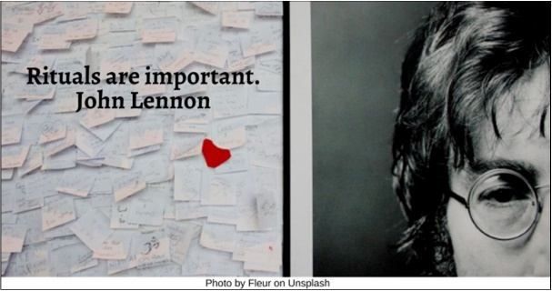

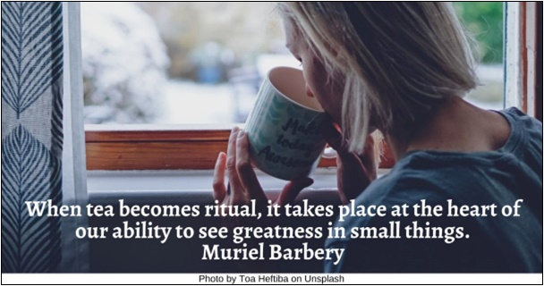

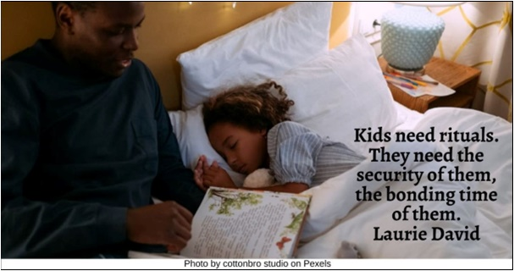

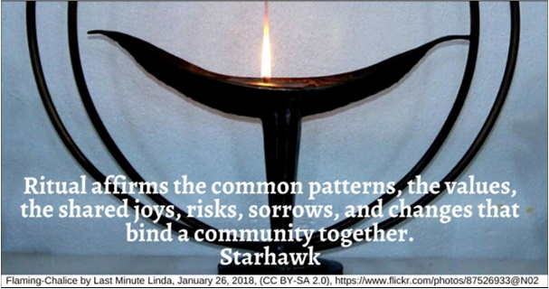

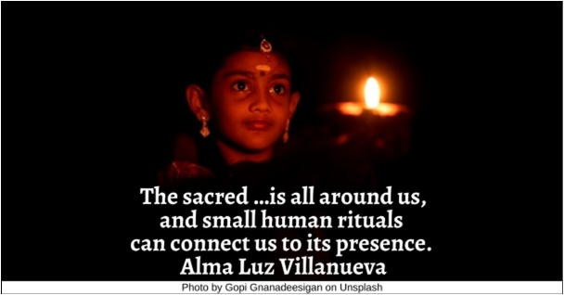

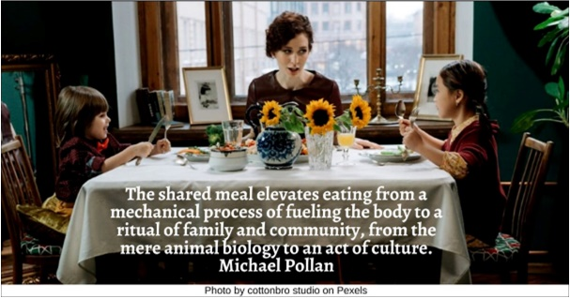

Resources for Children
2.0: Wisdom Stories
The Tapestry of Faith stories are not listed since those are easily accessible in the curricula listed at 4.0 & 5.0:

2.1: This Must be Sufficient by Elie Wiesel (237 words)
When the great Rabbi Israel Ba’al Shem-Tov saw misfortune threatening the Jews, it was his custom to go into a certain part of the forest to meditate. There he would light the fire, say a special prayer, and the miracle would be accomplished and the misfortune averted.
Years later when a disciple of the Ba’al Shem-Tov, the celebrated Magid of Mezritch, had occasion for the same reason, to intercede with heaven, he would go to the same place in the forest and say: “Master of the Universe, listen! I do not know how to light the fire, but I am still able to say the prayer,” and again the miracle would be accomplished.
Still later, another rabbi, Rabbi Moshe-leib of Sasov, in order to save his people once more, would go into the forest and say, “I do not know how to light the fire. I do not know the prayer, but I know the place and this must be sufficient.” It was sufficient and the miracle was accomplished.
The years passed. And it fell to Rabbi Israel of Ryzhyn to overcome misfortune. Sitting in his armchair, his head in his hands, he spoke to God: “I am unable to light the fire, and I do not know the prayer, and I cannot even find the place in the forest. All I can do is tell the story, and this must be sufficient.” And it was sufficient.
Source: https://www.uua.org/re/tapestry/adults/life/workshop2/159144.shtml, from The Gates of the Forest by Elie Wiesel

3.0: Children’s Books
Family Rituals
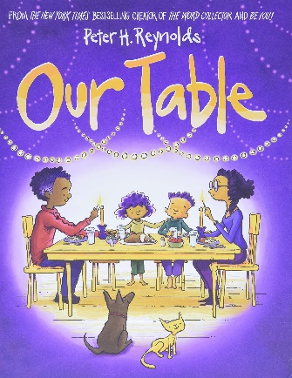
3.1: Our Table by Peter H. Reynolds (Author, Illustrator) 2021
“Violet longs for the time when her family was connected: before life, distractions, and technology pulled them all away from each other. They used to gather at the table, with food and love, to make memories, share their lives, and revel in time spent together. But now her family has been drifting apart, and with nobody to gather around it, the table grows smaller and smaller.
“Can Violet remind her family of the warmth of time spent together, and gather around the table once more?
“A mystical fable that feels at once timeless and utterly of the present moment, Our Table is renowned, bestselling creator Peter H. Reynolds at his best. Exquisite, expressive watercolor tells a tender story, growing from monochrome into luscious, joyful color as Violet’s family is reunited around the beloved table. An ode to traditions that unite families, Our Table brings readers together with a universal message of gratitude.”
Video Link: https://www.youtube.com/watch?v=N7D3pWc3T4E&t=50s (4:22)

Holidays & Holy Days

3.2: Let’s Celebrate!: Special Days Around the World by Kate DePalma (Author) and Martina Peluso (Illustrator) (2019)

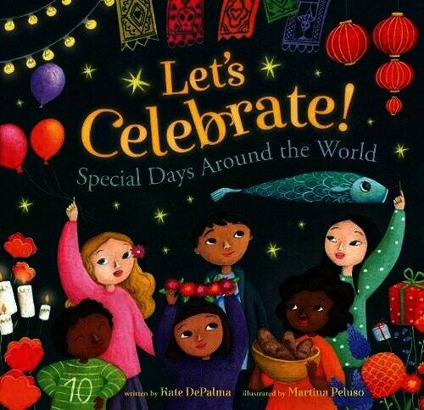
“Lyrical, sensory nonfiction text and vibrant illustrations invite readers to experience a child’s-eye view of 13 holidays around the world, such as the Spring Festival in China, Inti Raymi in Peru, Eid al-Fitr in Egypt, Día de Muertos in Mexico and the New Yam Festival in Nigeria. Includes pronunciation guides, a global festival calendar and educational notes about why we celebrate.”

Video Link: https://www.youtube.com/watch?v=OT0uaNKvjQQ (5:57)

3.3: Our Favorite Day of the Year by A. E. Ali (Author) and Rahele Jomepour Bell (Illustrator) (2020)

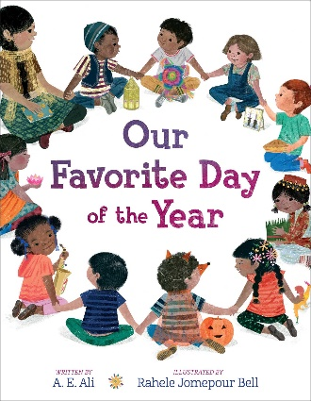
“Musa’s feeling nervous about his first day of school. He’s not used to being away from home and he doesn’t know any of the other kids in his class. And when he meets classmates Moisés, Mo, and Kevin, Musa isn’t sure they’ll have much in common. But over the course of the year, the four boys learn more about each other, the holidays they celebrate, their favorite foods, and what they like about school. The more they share with each other, the closer they become, until Musa can’t imagine any better friends.

“In this charming story of friendship and celebrating differences, young readers can discover how entering a new friendship with an open mind and sharing parts of yourself brings people together. And the calendar of holidays at the end of the book will delight children as they identify special events they can celebrate with friends throughout the year.”

Video Link: https://www.youtube.com/watch?v=zyzHHCoggk0 (5:42)

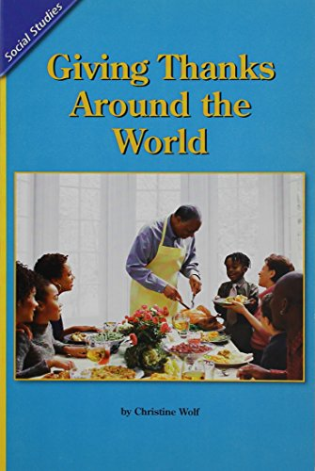
3.4: Giving Thanks Around the World by Christine Wolf (2007)

Through words and photos this book focuses on Thanksgiving in the U.S, the Yam Festival in Ghana and Nigeria, the Moon Festival (aka Mid-Autumn) in China, and the Pongal Festival in Southern India.

Video Link: https://www.youtube.com/watch?v=r47Ch0CgyHI (4:23)

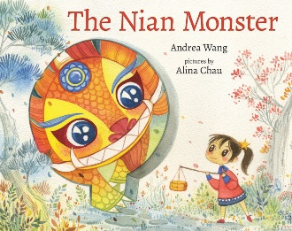
3.5: The Nian Monster by Andrea Wang (Author), Alina Chau (Illustrator) (2016)

“Tong tong! The legendary Nian monster has returned at Chinese New Year. With horns, scales, and wide, wicked jaws, Nian is intent on devouring Shanghai, starting with Xingling! The old tricks to keep him away don’t work on Nian anymore, but Xingling is clever. Will her quick thinking be enough to save the city from the Nian Monster?”

Video Link: https://www.youtube.com/watch?v=MVLv6IwRlUg (7:48)

Pagan Holidays and Rituals

3.6: Rupert’s Tales: The Wheel of the Year Beltane, Litha, Lammas, and Mabon by Kyrja (Author) and Tonia Bennington Osborn (Illustrator) (2011)

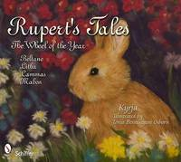
“A groundbreaking story that collects, commemorates, and illuminates traditional, sacred Pagan practices and beliefs in a fresh, contemporary, and whimsical style. Join Rupert the rabbit on his adventures as he sets out to discover how and why people leave their homes to celebrate seasonal holidays in the forest where he lives. As Rupert’s journey unfolds throughout the seasons, he meets owls, fairies, and old friends who teach him about the Wheel of the Year.”

Video Link about Beltane, May Day: https://www.youtube.com/watch?v=GE7R18o_zXM (12:41)

Video Link about Litha, the Summer Solstice, June 20 or 21: https://www.youtube.com/watch?v=1RSxWcMyUd4 (11:30)

Video Link about Lammas, Harvest Festival, August 1: https://www.youtube.com/watch?v=PFP6bOKSfMc (7:03)

Video Link about Mabon, Autumnal Equinox, September 21 up to 24: https://www.youtube.com/watch?v=FbQM1s-4Yf0 (14:48)

3.7: Rupert’s Tales: The Wheel of the Year - Samhain, Yule, Imbolc, and Ostara by Kyrja (Author) and Tonia Bennington Osborn (Illustrator) (2012)
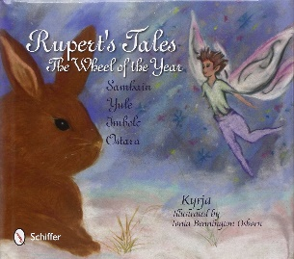
“Come along with Rupert the rabbit as he again travels through the Wheel of the Year. In this second book of adventures, he learns about tolerance, respect, and acceptance, and discovers how people celebrate seasonal holidays in the forest where he lives. The tales (one for each season – Samhain, Yule, Imbolc, and Ostara) set the stage for our furry friend to understand the importance of the seasons and that remembering love and laughter is always wise. He learns about decorations, songs, symbols, and how important the sun and its warmth really are. Join Rupert as he meets a new fairy friend and lots of girls and boys. Find out how someone very special steals Rupert’s heart! Perfect for teaching sacred Pagan practices and beliefs to young children being raised within varied traditions. Rupert’s Tales are stories for all children, everywhere!”
Video Link about Samhain, Halloween/All Souls, October 31-November 1: https://www.youtube.com/watch?v=roikQsFuMYU (15:38)

Video Link about Yule, Winter Solstice, December 21 or 22: https://www.youtube.com/watch?v=r_iPocXhc4Q (15:40)

Video Link about Imbolc, aka Saint Brigid’s Day, February 1: https://www.youtube.com/watch?v=oEH33Rxsm0E (14:42)

Video Link about Ostara, Spring Equinox, March 19, 20, or 21: https://www.youtube.com/watch?v=tlh5R6dNdgg (12:57)

Indigenous People’s Day

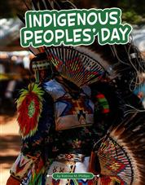
3.8: Indigenous Peoples’ Day by Katrina M. Phillips (2021)

“Indigenous Peoples’ Day is about celebrating! The second Monday in October is a day to honor Native American people, their histories, and cultures. People mark the day with food, dancing, and songs. Readers will discover how a shared holiday can have multiple traditions and be celebrated in all sorts of ways.” This book refers to the celebration in the U.S. on the second Monday in October. The celebration in Canada happens on June 21st, the Summer Solstice.

Video Link: https://www.youtube.com/watch?v=4qMBrKDmKQc (6:09)

3.9: We Are Grateful: Otsaliheliga by Traci Sorel, (Author) and Frane Lessac (Illustrator) (2018)
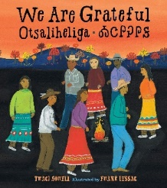
”The word otsaliheliga (oh-jah-LEE-hay-lee-gah) is used by members of the Cherokee Nation to express gratitude. Beginning in the fall with the new year and ending in summer, follow a full Cherokee year of celebrations and experiences. Written by a citizen of the Cherokee Nation, this look at one group of Native Americans is appended with a glossary and the complete Cherokee syllabary, originally created by Sequoyah.”

Video Link: https://www.youtube.com/watch?v=tUYe12tOqhQ (4:09)

Lesson Plan: https://www.readacrossamerica.org/we-are-grateful-otsaliheliga/

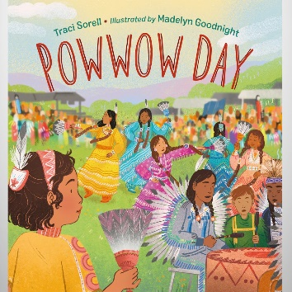
3.10: Powwow Day by Traci Sorell (Author) and Madelyn Goodnight (Illustrator) (2022)

“River wants so badly to dance at powwow day as she does every year. In this uplifting and contemporary picture book perfect for beginning readers, follow River’s journey from feeling isolated after an illness to learning the healing power of community.

“Additional information explains the history and functions of powwows, which are commonplace across the United States and Canada and are open to both Native Americans and non-Native visitors. Author Traci Sorell is a member of the Cherokee Nation, and illustrator Madelyn Goodnight is a member of the Chickasaw Nation.

Video Link: https://www.youtube.com/watch?v=ZVj1Bs7msAo (5:26)

3.11: Remember by Joy Harjo (Author) and Michaela Goade (Illustrator) (2023)

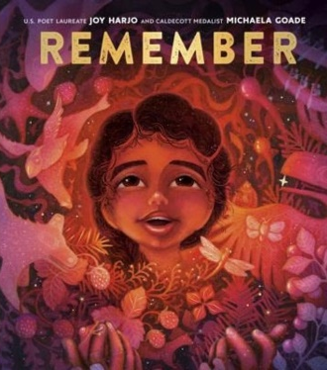
“Remember the sky you were born under,

Know each of the star’s stories.

Remember the moon, know who she is.

Remember the sun’s birth at dawn,

That is the strongest point of time.

“So begins the picture book adaptation of the renowned poem that encourages young readers to reflect on family, nature, and their heritage. In simple and direct language, Harjo, a member of the Mvskoke Nation, urges readers to pay close attention to who they are, the world they were born into, and how all inhabitants on earth are connected. Michaela Goade, drawing from her Tlingit culture, has created vivid illustrations that make the words come alive in an engaging and accessible way.”

Video Link: https://www.youtube.com/watch?v=U5FJ64I5wO4 (1:58)

3.12: I Sang You Down from the Stars by Tasha Spillett-Sumner (Author) and Michaela Goade (Illustrator) (2021)

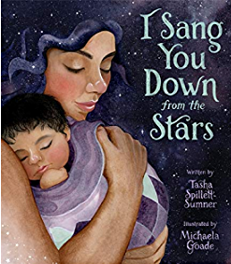
“As she waits for the arrival of her new baby, a mother-to-be gathers gifts to create a sacred bundle. A white feather, cedar and sage, a stone from the river . . .

“Each addition to the bundle will offer the new baby strength and connection to tradition, family, and community. As they grow together, mother and baby will each have gifts to offer each other.

“Tasha Spillett-Sumner and Michaela Goade, two Indigenous creators, bring beautiful words and luminous art together in a resonant celebration of the bond between mother and child.”

Video Link: https://www.youtube.com/watch?v=OyFHRN1nJ_Q (3:35)

3.13: First Laugh: Welcome, Baby! by Rose Ann Tahe & Nancy Bo Flood (Authors) and Jonathan Nelson (Illustrator) (2018)

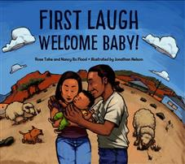
“The First Laugh Ceremony is a celebration held to welcome a new member of the community. As everyone--from Baby’s nima (mom) to nadi (big sister) to cheii (grandfather)--tries to elicit the joyous sound from Baby, readers are introduced to details about Navajo life and the Navajo names for family members. Back matter includes information about other cultural ceremonies that welcome new babies and children, including man yue celebration (China), sanskaras (Hindu) and aquiqa (Muslim).”

Video Link: https://www.youtube.com/watch?v=4D_Mw3on0qU (7:00)

3.14: Keepunumuk: Weeâchumun’s Thanksgiving by Danielle Greendee, Anthony Perry & Alexis Bunten (Authors) and Gary Meeches Sr (Illustrator) (August 2022)
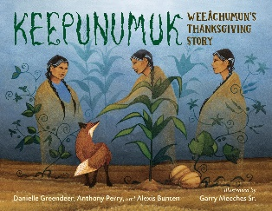
“In this Wampanoag story told in a Native tradition, two kids from the Mashpee Wampanoag tribe learn the story of Weeâchumun (corn) and the first Thanksgiving.
“The Thanksgiving story that most Americans know celebrates the Pilgrims. But without members of the Wampanoag tribe who already lived on the land where the Pilgrims settled, the Pilgrims would never have made it through their first winter. And without Weeâchumun (corn), the Native people wouldn’t have helped.
“An important picture book honoring both the history and tradition that surrounds the story of the first Thanksgiving.”
“Wispy, dreamlike illustrations complement this tale of the first Thanksgiving from a Wampanoag perspective. Weeâchumun, the wise corn, and her sisters, Beans and Squash, are considered the three sisters of the harvest. When Weeâchumun sees the settlers arrive, she tasks Fox to watch them through the winter. When spring returns, Fox reports the newcomers are hungry and struggling, and the sisters send the First Peoples to their aid, setting history into motion.”
Video Link: https://www.youtube.com/watch?v=fkXuVfoq050 (11:57)
In Conversation with the Creators of Keepunumuk, Video Link: https://www.youtube.com/watch?v=v7vwa6IHPk8 (22:13) Author Danielle Greendeer is a Mashpee Wampanoag citizen. Author Anthony Perry is a Chickasaw citizen. Author Alexis Bunten is Alaskan Native (Yu’pik & Unangan). Canadian illustrator Garry Meeches Sr. is an Anishinaabe citizen.
Text of interview with the authors: https://www.forewordreviews.com/articles/article/four-native-american-creators-weave-together-the-story-of-keepunumuk-the-time-of-harvest/
Down to Earth: A Review of Keepunumuk: Weeâchumun’s Thanksgiving Story: https://butlerspantry.org/2022/07/14/down-to-earth-a-review-of-keepunumuk-weeachumuns-thanksgiving-story/ (excellent overview)

Juneteenth
3.15: All Different Now: Juneteenth, the First Day of Freedom by Angela Johnson, author & E.B. Lewis, illustrator (2014)
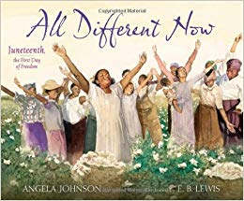
”Through the eyes of one little girl, All Different Now tells the story of the first Juneteenth, the day freedom finally came to the last of the slaves in the South. Since then, the observance of June 19 as African American Emancipation Day has spread across the United States and beyond. This stunning picture book includes notes from the author and illustrator, a timeline of important dates, and a glossary of relevant terms.”
Video Link: https://www.youtube.com/watch?v=iOvi3j26ZDc (4:10)

3.16: Opal Lee and What It Means to Be Free: The True Story of the Grandmother of Juneteenth by Alice Faye Duncan (Author), Keturah A. Bobo (Illustrator) (2022)

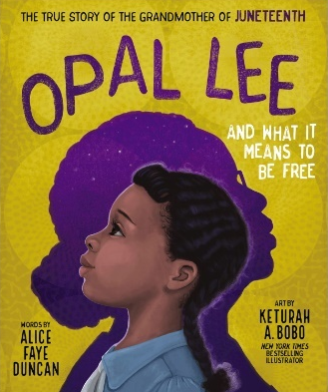
“Every year, Opal looked forward to the Juneteenth picnic—a drumming, dancing, delicious party. She knew from Granddaddy Zak’s stories that Juneteenth celebrated the day the freedom news of President Lincoln’s Emancipation Proclamation finally sailed into Texas in 1865—over two years after the president had declared it! But Opal didn’t always see freedom in her Texas town. Then one Juneteenth day when Opal was twelve years old, an angry crowd burned down her brand-new home. This wasn’t freedom at all. She had to do something! But could one person’s voice make a difference? Could Opal bring about national recognition of Juneteenth? Follow Opal Lee as she fights to improve the future by honoring the past.”

Video Link: https://www.youtube.com/watch?v=-kSA1nbu-SE (9:19)
Ms. Opal Lee: https://www.youtube.com/watch?v=3jsR53gIOZs (2:42)

Origin Stories and Other Myths

3.17: Creation by Cynthia Rylant (Author, Illustrator) (2016)

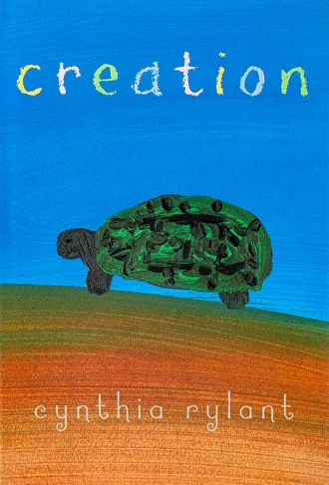
“Cynthia Rylant takes the familiar text of the creation story, as told in the King James Bible, and lovingly illustrates it in her simple but bold style that has been called “stunning” by School Library Journal. In striking illustrations reminiscent of folk art, Rylant has created a fresh take on a classic story that will appeal to readers of all ages.”

Video Link: https://www.youtube.com/watch?v=c9AqaY7N2u0 (3:54)

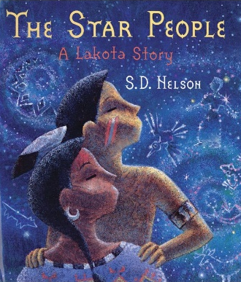
3.18: The Star People: A Lakota Story by S. D. Nelson (2003)

“Sister Girl and her brother Young Wolf wander away from their village and soon find themselves far out in the surrounding prairie. They sit down in the grass and watch the clouds passing above billow to form an eagle, horses, and other creatures. Suddenly, animals begin to race past the children on the ground—followed by a wall of fire! Fleeing along with the frightened beasts, Sister Girl and Young Wolf save themselves by tumbling into a shallow stream.

“The fire leaves behind ash and a barren, forbidding landscape. The children realize that they are hopelessly lost. Night is coming—how will they get home to their parents? And why are the evening stars dancing so?

Video Link: https://www.youtube.com/watch?v=tHbUolQqBEg (11:39)

3.19: We Are Water Protectors by Carole Lindstrom (Author) and Michaela Goade (Illustrator) (2020)
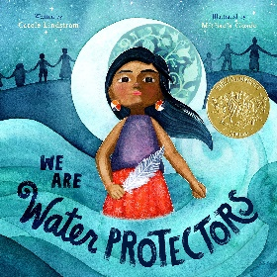
“Inspired by the many Indigenous-led movements across North America, We Are Water Protectors issues an urgent rallying cry to safeguard the Earth’s water from harm and corruption….
“‘Water is the first medicine. It affects and connects us all . . .’
“When a black snake threatens to destroy the Earth
And poison her people’s water, one young water protector
Takes a stand to defend Earth’s most sacred resource.”
Video Link: https://www.youtube.com/watch?v=tJLnvSjvkus (3:52)

3.20: Why the Sun and the Moon Live in the Sky by Elphinstone Dyrell (Author) and Blair Lent (Illustrator) (1990)

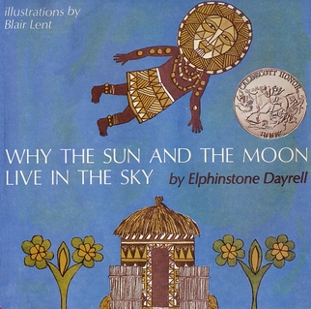
Sun and his wife, the moon, lived on Earth and built a large house so that the water people could visit. But so many poured in that they were forced to move to the sky.

Video Link: https://www.youtube.com/watch?v=2kRPItyud_c (4:18)

Pride

3.21: Pride: The Story of Harvey Milk and the Rainbow Flag by Rob Sanders (Author) and Steven Salerno (Illustrator) (2018)

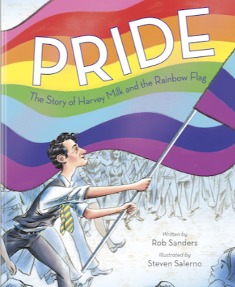
“In this deeply moving and empowering true story, young readers will trace the life of the Gay Pride Flag, from its beginnings in 1978 with social activist Harvey Milk and designer Gilbert Baker to its spanning of the globe and its role in today’s world.”

Video Link: https://www.youtube.com/watch?v=2bNhkOCyDIY&t=39s (8:37)

3.22: Twas the Night Before Pride by Joanna McClintick (Author) and Juana Medina (Illustrator) (2022)

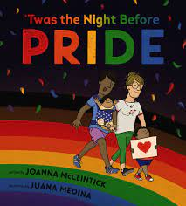
“This joyful picture-book homage to a day of community and inclusion—and to the joys of anticipation—is also a comprehensive history. With bright, buoyant illustrations and lyrical, age-appropriate rhyme modeled on “‘Twas the Night Before Christmas,” it tackles difficult content such as the Stonewall Riots and the AIDS marches. On the night packs snacks and makes signs, an older sibling shares the importance of the march with the newest member of the family. Reflecting on the day, the siblings agree that the best thing about Pride is getting to be yourself.”

Video Link: https://www.youtube.com/watch?v=_274bLQn38I (3:42)

3.23: This Day in June by Gayle E. Pitman (Author) and Kristyna Litten (Illustrator) (2014)

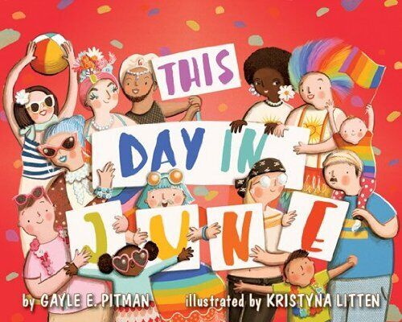
“In a wildly whimsical, validating, and exuberant reflection of the LGBTQ+ community, This Day In June welcomes readers to experience a pride celebration and share in a day when we are all united. Also included is a Note to Parents and Other Caregivers with information on how to talk to children about sexual orientation and gender identity in age-appropriate ways as well as a Reading Guide chock-full of facts about LGBTQ+ history and culture.”
Video Link: https://www.youtube.com/watch?v=7It6cFUW5FM (2:28)

4.0: Curriculum & Theme-Based Classroom Activities for Children

from Tapestry of Faith
4.1: Chalice Children: A Program about Our Unitarian Universalist Community for Preschoolers
4.1.1: Session 4: Making Chalices
Link: https://www.uua.org/re/tapestry/children/chalicechildren/session4
The flaming chalice is a symbol of our faith, and a ritual that binds us together.
“Participants will:
- Become familiar with the chalice as a symbol of our Unitarian Universalist faith. See story about the flaming chalice at https://www.uua.org/re/tapestry/children/home/session2/60017.shtml
- Begin to develop a sense of identity as a Unitarian Universalist
- Begin to understand that there are many ways to express religion.”
4.1.2: Session 6: Chalice Necklaces
Link: https://www.uua.org/re/tapestry/children/chalicechildren/session6
The flaming chalice is a symbol of our faith, which is why learning the story of its creation and its meaning as a ritual is so important.
“Participants will:
- Reinforce their understanding of the chalice as a symbol of their Unitarian Universalist faith. See story about the flaming chalice at https://www.uua.org/re/tapestry/children/chalicechildren/session6/297973.shtml
- Connect wonder, peace, love, and joy with the chalice
- Learn the song I’ve Got Peace Like a River.”
4.1.3: Session 8: Fruit Chalices
Link: https://www.uua.org/re/tapestry/children/chalicechildren/session8
The flaming chalice is a symbol of our faith and our most visible ritual.
“Participants will:
- Explore the shape and parts of the chalice, using edible fruit
- Reinforce their understanding of the chalice as the symbol of Unitarian Universalism. See story about the flaming chalice at https://www.uua.org/re/tapestry/children/home/session2/60017.shtml
- Feel connected to the chalice and to their Chalice Children group.”
4.1.4: Session 16: Special Worship Services
Link: https://www.uua.org/re/tapestry/children/chalicechildren/session16
The Flower Communion is a ritual that binds us together as a congregation. It is 100 years old in 2023.
“Participants will:
- Learn about the Flower Communion
- Explore the sensory elements of a special worship service
- Feel themselves to be a part of the larger faith community by participating in and helping with the special service
- Understand that Unitarian Universalists near and far have special services in common.”

4.2: Creating Home: A Program on Developing a Sense of Home Grounded in Faith for Grades K-1
4.2.1: Session 2: Symbols of Faith
Link: https://www.uua.org/re/tapestry/children/home/session2
The flaming chalice is a symbol of our faith, which is why learning the story of its creation and its meaning as a ritual is so important.
“Participants will:
- Create a personal faith symbol or decorate a chalice
- Construct a chalice as a symbol of their faith home to use in their family home
- Listen and interact with the story, Flame of Learning, Chalice of Love. Explore the meaning of the components of the chalice symbol
- Learn the hymn, Spirit of Life
- Create personal symbols of faith
- Optional: Internalize the chalice story by participating in a Faith in Action project involving refugees”
4.2.2: Session 16: Memories of Home
Link: https://www.uua.org/re/tapestry/children/home/session16
In the story, The Memory Table, a chalice is an important symbol and ritual, which can promote a conversation about the lighting of a chalice.
“This session will:
- Help each child articulate their unique contributions to their family home and faith home
- Model ways to articulate, honor, and rely upon one’s memories of home with activities that provide closure to the Creating Home “journey”
- Convey that memories of our Unitarian Universalist faith home and our family home can sustain us in our daily lives”

4.3: Wonderful Welcome: A Program for Children Grades K-1
4.3.1: Session 14: The Gift Of Spirit
Link: https://www.uua.org/re/tapestry/children/welcome/session14
Lighting the chalice is a powerful ritual in our tradition.
“Participants will:
- Experience themselves as people who can give and receive the intangible gift of spirit as they learn ways to do so
- Learn and sing the song, “This Little Light of Mine”
- Affirm each other’s spirits and spiritual selves through the beliefs and values continuum game
- Make a chalice.
- Engage in the spiritual practices of chalice lighting, sharing of joys and concerns, and intentional discussion, with a focus on how these acts express a sharing of spirit.”

4.4: Love Surrounds Us: A Program on the UU Principles and Beloved Community for Grades K-1
4.4.1: Session 7: Love Surrounds Us in Ritual
Link: https://www.uua.org/re/tapestry/children/lovesurrounds/session7
Rituals are an important part of remembrance. In this session the focus on the flower ceremony connects children with an important part of our history.
“Participants will:
- Learn that ritual serves the purpose of gathering people in shared faith
- Learn the origin of the flower ceremony and its role in contemporary Unitarian Universalist worship
- Experience a ritual that affirms acceptance and love, by participating in a flower ceremony.”
4.4.2: Session 9: Love Surrounds Us in Our Search
Link: https://www.uua.org/re/tapestry/children/lovesurrounds/session9
The flaming chalice is our most visible sacred symbols.
“Participants will:
- Learn that Unitarian Universalist beliefs come from many different sources
- Understand that sacred symbols have meaning and purpose in a variety of religious traditions
- Represent their own important feelings as symbols
- Make a sand painting of a flaming chalice”

4.5: Moral Tales: A Program on Making Choices for Grades 2-3
4.5.1: Session 3: Faith, Hope and Prayer
Link: https://www.uua.org/re/tapestry/children/tales/session3
Through prayer, in the story The Wooden Sword, the Jew expresses his trust in God and finds answers to overcome each dilemma created by the shah. Prayer is ritual shared by diverse people throughout the world.
This session will:
- Introduce prayer as a powerful, optional spiritual practice
- Establish the importance of — and demonstrate how to give and receive — respect for all expressions of personal faith, regardless of personal beliefs or religious practices
- Engage participants in experiencing different types of prayer
- Explore the idea that actions can bring our prayers and wishes closer to reality
- Introduce and explicate a prayer bead necklace
- Highlight the third Unitarian Universalist Principle, acceptance of one another and encouragement of spiritual growth in our congregations

4.6: Faithful Journeys: A Program about Pilgrimages of Faith in Action for Grades 2-3
4.6.1: Session 7: Create Magic, Change the World
Link: https://www.uua.org/re/tapestry/children/journeys/session7
The story, The Perfect Peace Harvest, occurs on Lammas, the pagan harvest holiday.
“This session will:
- Teach that we express our third Unitarian Universalist Principle, acceptance of one another and encouragement to spiritual growth, in our congregations when we engage in spiritual practices that include and promote active involvement in the world
- Strengthen Unitarian Universalist identity through connection with our sixth Source, spiritual teachings of Earth-centered traditions that celebrate the sacred circle of life and instruct us to live in harmony with the rhythms of nature
- Include a story about a child who models courage as she faces her fear and speaks publicly at a peace rally
- Demonstrate the idea that faithful intention and focusing our energy can be tools for practicing ‘magic’ for the benefit of the world
- Teach children how their own actions can and do express their faith — their ideas of right and wrong, their values and their beliefs.”

4.7: Love Will Guide Us: A Program for Grades 2-3 that Applies the Wisdom of the Six Sources to the Big Questions
4.7.1: Session 11: Love and Gratitude
Link: https://www.uua.org/re/tapestry/children/loveguide/session11
The return of the sun was/is embedded in memory, but also in the action of children in the story, The Rebirth of the Sun. While focused on the winter solstice, it also opens the opportunity to explore the summer solstice.
“This session will:
- Present a lesson about gratitude based in the sixth Unitarian Universalist Source, ‘the harmony of nature and the sacred circle of life’
- Demonstrate our connections to the rhythms of nature through a story about the winter solstice
- Cultivate in children an ‘attitude of gratitude’ and provide opportunities to express thanksgiving
- Foster an ethic of caring for the Earth by promoting awareness of and gratitude for the gifts we receive from nature
- Teach a way to express gratitude so it is personalized, specific, and meaningful.”
Another intriguing story is told in the book Usha and the Stolen Sun by Bree Galbraith (Author) and Josée Bisaillon (Illustrator) (2020). See a reading of the book at https://www.youtube.com/watch?v=gMCPUDosYBk (4:59). A key part of the story happens when Usha begins telling her grandfather’s stories.

4.8: Signs of Our Faith: A Program about Being UU Every Day for Grades 2-3
4.8.1: Session 1: Signs, Symbols, and Rituals
Link: https://www.uua.org/re/tapestry/children/signs/session1
This session explores the concept of ritual.
“Participants will:
- Understand “ritual” by naming the rituals they engage in each day
- Become familiar with terms that will recur throughout the program: sign, ritual, symbol, and abstract
- Through hands-on activities, learn how religious rituals and signs represent abstract ideas.”
4.8.2: Session 5: We Revere Life
Link: https://www.uua.org/re/tapestry/children/signs/session5
The celebration of birth through a child dedication ceremony can evoke memories of when children were younger. This rite of passage is an important ritual.
“Participants will:
- Appreciate the miracle of birth and new beginnings
- Learn UU ways to express reverence for life
- Learn how the congregation and the families in it celebrate births and beginnings
- Understand what it means to ‘dedicate.’”
4.8.3: Session 7: We Share
Link: https://www.uua.org/re/tapestry/children/signs/session7
This session explores the ritual of communion as adapted by Unitarian Universalists.
“Participants will:
- Identify themselves as people who know how and why to share
- Understand UU rituals: Flower Communion, Water Communion, Bread Communion, etc.
- Experience saying a grace over food as a ritual that affirms sharing
- Acknowledge sharing as a religious value and commit to sharing as a way to be UU every day.”
4.8.4: Session 8: Memorial Rituals
Link: https://www.uua.org/re/tapestry/children/signs/session8
This session focuses on death and rituals of remembrance.
“Participants will:
- Create a memorial ritual
- Understand that death is a part of life
- Understand that while Unitarian Universalist memorial rituals vary, all share the goals of helping us (1) acknowledge our loss and (2) celebrate the loved one’s life—indeed, all life—as sacred
- Discover rituals and signs their UU congregation uses when someone dies
- Explore the concept of a person living on after their physical death in other people’s remembered experiences of them, through a story of Jesus.”

4.9: Toolbox of Faith: A Program That Helps Children Discover the Uses of Faith, Grades 4-5
4.9.1: Session 9: Spirit Of Life (Canteen)
Link: https://www.uua.org/re/tapestry/children/toolbox/session9
Enacting the Water Communion offers the opportunity to explore an important ritual.
“Participants will:
- Explore the qualities of water through discussion and hands-on experiences
- Make a symbolic connection between the fluidity and pervasiveness of water and the fluidity and pervasiveness of the Spirit of Life
- Develop a personal sense of the Spirit of Life, by reaching into our Jewish and Christian heritage, our Unitarian Universalist love of reason, and our willingness to seek the divine in everything
- Reenact the water communion through visualization and emphasize how all water is connected, just as all things are connected by the Spirit of Life
- Learn the Unitarian Universalist hymn, Spirit of Life
- Focus on one of the sources of the Unitarian Universalist Living Tradition, ‘the direct experience of that transcending mystery and wonder, affirmed in all cultures, which moves us to a renewal of the spirit and an openness to the forces which create and uphold life’”

4.10: Windows and Mirrors: A Program about Diversity for Grades 4-5
4.10.1: Session 15: Prayer Is A Place to Grow A Soul
Link: https://www.uua.org/re/tapestry/children/windows/session15
This session explores the ritual of prayer.
“Participants will:
- Understand a Unitarian Universalism definition of prayer
- Explore purposes and meanings of prayer through a Unitarian Universalist lens
- Experience several prayer practices and rituals, expanding their cultural literacy about various faiths’ and cultures’ practices
- Reflect on how various approaches to prayer do or might serve their own spiritual needs and their search for truth and meaning
- Demonstrate respect for the religious practices of others.”

4.11: Sing to the Power: A Social Justice Program for Children Grades 4-5

4.11.1: Session 6: The Power of Presence

Link: https://www.uua.org/re/tapestry/children/sing/session6
The story, “The Presence of Angels,” is related to the shooting of Rep. Gabrielle Giffords (in January 2011.) The funeral service of nine-year-old Christina Taylor-Green was transformed by people who wanted to make sure that her memory was honored.
“Participants will:
- Understand how a silent vigil of justice advocates wearing angel wings, planned by a Unitarian Universalist, shows air power
- Understand civil disobedience as promoted by Henry David Thoreau, Mohandas Gandhi, and the Rev. Dr. Martin Luther King as expressions of air power
- Experience a sense of silent presence, through a game
- Prepare to give someone else an expression of supportive presence, by creating blankets
- Explore ways to practice prayer as a ministry of presence.”

4.12: Riddle and Mystery: A Program on the Big Questions for Grade 6
4.12.1: Session 6: Thinking of Death
Link: https://www.uua.org/re/tapestry/children/riddle/session6
Reflecting on death and the loss of loved ones who have died are important as is the creating of a meaningful ritual to honor of the memory of a loved one who has died..
“Participants will:
- Compare and contrast death beliefs of various religions
- Learn the perspective of a contemporary Unitarian Universalist theologian
- Consider the concept that we live on, after death, through our actions in life and in the love and memories of others
- Reflect on their own ideas about death
- Plan and/or experience a ritual to recognize the deaths of individuals in their congregation, family or community.”
4.12.2: Session 16: UU Me
Link: http://www.uua.org/re/tapestry/children/riddle/session16
The activity of forming a human chalice is a ritual that reinforces the importance of the chalice as a symbol and ritual in our faith.
“Participants will:
- Deepen their understanding of religion, spirituality, faith and faith community, and how these concepts apply to their own lives
- Gain ideas about what Unitarian Universalism does or can mean to them
- Articulate what Unitarian Universalism means to them in a simple statement
- Create a human chalice
- Celebrate the conclusion of Riddle and Mystery.”

4.13: Miracles: A Multigenerational Program on Living in Awe and Wonder
4.13.1: Session 6: The Miracle of Social Change
Link: https://www.uua.org/re/tapestry/multigenerational/miracles/session-6
The story, A Lamp in Every Corner, offers an opportunity to thoughtfully explore the meaning of the flame in the flaming chalice.
“Participants will:
- Explore what they believe constitutes a ‘miracle’ as they share experiences of ‘miracle moments’
- Feel empowered as agents for change through the metaphor of the ripple effect in water
- Identify community and global situations that ‘need a miracle’ and explore how individual action, grounded in love, could create the needed transformation.”

4.14: Families: A Jr. High School Youth Program that Explores the Diversity, Commonality, and Meaning of Families
4.14.1: Workshop 8: Families Function: Families Eat
Link: https://www.uua.org/re/tapestry/youth/families/workshop8
Food and the table at which a family eats often involve simple rituals that can be very meaningful.
“Participants will:
- Explore the meaning and role of food in families
- Explore differences and similarities between families
- Create representations of families through different artistic media
- Learn more deeply about how looking at families through only one-lens— food—affects what we can learn about families and the representation of them”

4.15: Building Bridges: A World Religions Program for 8th-9th Grades
4.15.1: Workshop 3: Indigenous Religions: The Earth Speaks
Link: https://www.uua.org/re/tapestry/youth/bridges/workshop3
The aboriginal creation story, Sun Mother Walks the Earth, specifically, and this session generally introduces an indigenous religion.
“Participants will:
- Deepen their understanding of the purposes of religion
- Become familiar with and able to discuss universal features of indigenous religions
- Hear and discuss an aboriginal Australian Dreamtime story
- Experience some strengths of oral tradition through sharing personal accounts
- Build appreciation for world views different from their own.”
4.15.2: Workshop 21: Neo-Paganism: The Sacredness of Creation
Link: https://www.uua.org/re/tapestry/youth/bridges/workshop21
For Neo-Paganism, “The cycles of nature are our holy days, the earth is our temple, its plants and creatures our partners and teachers. This focus can be an aid in eliciting awe.
“Participants will:
- Understand how Neo-Paganism relates to ancient Pagan religions
- Explore aspects of Wicca and Neo-Paganism
- Discover the organization Covenant of UU Pagans and consider how Unitarian Universalism can be a welcoming place for pagans.”

Resources for Youth
5.0: Curriculum & Theme-Based Classroom Activities for Youth
Tapestry of Faith
Youth
5.1: A Chorus of Faiths: A Program That Builds Interfaith Youth Leaders
5.1.1: Workshop 2: We Need Not Think Alike to Love Alike
Link: https://www.uua.org/re/tapestry/youth/chorus/workshop2/173577.shtml
The story, Righteous Among the Nations, is about Waitsill and Martha Sharp and the flaming chalice, which is both symbol and ritual.
“Participants will:
- Understand the Golden Rule as an example of a Unitarian Universalist value inherited from our Judeo-Christian tradition
- Learn the story of the Unitarian Universalist flaming chalice symbol and hear about the interfaith service work of Unitarians Martha and Waitstill Sharp during World War II
- Map their community’s assets for diverse, interfaith cooperation in service work
- Move the group’s interfaith service project forward by identifying potential partners and projects in their community
- Recognize and reflect on the importance of human similarities and differences.”

5.2: A Place of Wholeness: A Program for Youth Exploring Their Own Unitarian Universalist Faith Journeys
5.2.1: Workshop 4: A Theology of Love
Link: https://www.uua.org/re/tapestry/youth/wholeness/workshop4
The Rainbow flag is a LGBTQ+ symbol The ritual is carrying a flag or banner to demonstrate pride..
“Participants will:
- Understand the historical roots of the Universalist theology of love as it relates to salvation and God
- Reflect on what the Universalist theology of love means for them and for Unitarian Universalists today, including how they live it out; what its limits are, and what it says about evil
- Identify where a theology of love shows up in the Unitarian Universalist Principles and the actions of Unitarian Universalist congregations today.”
5.2.2: Workshop 5: Hope
Link: https://www.uua.org/re/tapestry/youth/wholeness/workshop5
The Flower Festival (aka Communion) is an important ritual in our faith.
“Participants will:
- Understand that hope and optimism are rooted in the Unitarian Universalist tradition and manifest in many ways
- Learn about and experience the Unitarian Universalist Flower Festival as an expression of hope
- Reflect on the role of hope in their lives and communities, making connections with current events
- Identify human and divine capacities that justify hope and optimism, and apply these to their beliefs and actions.”

6.0: Readings
6.1: A Ritual to Read to Each Other by William Stafford (189 words)
A powerful poem that begins, “If you don’t know the kind of person I am / and I don’t know the kind of person you are / a pattern that others made may prevail in the world / and following the wrong god home we may miss our star.”
Source: https://www.poetryfoundation.org/poems/58264/a-ritual-to-read-to-each-other

6.2: Flowers have the Gift of Language by Rev. Richard Gilbert (320 words)
Speak, flowers, speak!
Why do you say nothing?
The flowers have the gift of language.
In the meadow they speak of freedom,
Creating patterns wild and free as no gardener could match.
In the forest they nestle, snug carpets under the roof of
Leaf and branch, making a rug of such softness.
At end tip of branches they cling briefly
Before bursting into fruit sweet to taste.
Flowers, can you not speak joy to our sadness?
And hope to our fear?
Can you not say how it is with you
That you color the darkest corner?
The flowers have the gift of language.
At the occasion of birth they are buds before bursting.
At the ceremony of love they unite two lovers in beauty.
At the occasion of death, they remind us how lovely is life.
Oh, would that you had voice,
Silent messengers of hope.
Would that you could tell us how you feel,
Arrayed in such beauty.
The flowers have the gift of language.
In the dark depths of a death camp
They speak the light of life.
In the face of cruelty
They speak of courage.
In the experience of ugliness
They bespeak the persistence of beauty.
Speak, messengers, speak!
For we would hear your message.
Speak, messengers, speak!
For we need to hear what you would say.
For the flowers have the gift of language:
They transport the human voice on winds of beauty;
They lift the melody of song to our ears;
They paint through the eye and hand of the artist;
Their fragrance binds us to sweet-smelling earth.
May the blessing of the flowers be upon you.
May their beauty beckon to you each morning
And their loveliness lure you each day,
And their tenderness caress you each night.
May their delicate petals make you gentle,
And their eyes make you aware.
May their stems make you sturdy,
And their reaching make you care.
Source: https://www.uua.org/worship/words/reading/27759.shtml

6.3: This is My Body by Sue Monk Kidd (108 words)
I often went to Catholic mass or Eucharist at the Episcopal church, nourished by the symbol and power of this profound feeding ritual. It never occurred to me how odd it was that women, who have presided over the domain of food and feeding for thousands of years, were historically and routinely barred from presiding over it in a spiritual context. And when the priest held out the host and said, “This is my body, given for you,” not once did I recognize that it is women in the act of breastfeeding who most truly embody those words and who are also most excluded from ritually saying them.
Source: Goodreads

6.4: Flower Communion Meditation by Rev. Elizabeth Strong (114 words)
Enter into the communion of flowers.
Enter with joyful hearts.
Enter with reverent thoughts.
It has taken long months beneath
cold ground for these flowers
to prepare their blooming.
It has taken each of us long times
of growth through sorrow and joy
to prepare for our living now.
The blooming season is short,
The flowers stay only a brief time.
We are travelers upon the earth:
travelers through all to brief life times.
Therefore, let our moments be bountiful.
Let us rejoice in our unique colors, aromas, and sounds.
Let us celebrate together in love;
that as we travel away, we take with us
the memory of golden hours together
among the flowers.
Source: https://www.uua.org/worship/words/meditation/travelers-upon-earth

6.5: The Story of Us by Deb Caletti (123 words)
Stories help you understand your life, she’d say. Stories can heal. And I think she’s right, because why do old guys back from the war tell their experiences again and again? Why did people of long ago make up elaborate tales of mythical beings? Why do people sit in a room and reveal the pieces of their life to doctors trained to listen, and why are they cured by doing that? Why libraries? Come on, all those stories, pieces of life told again and again. We need them. Stories are a ritual that put all the crazy …about life into a form that makes sense. We’re all like the little kids that need to be read the same story over and over again.
Source: Goodreads

6.6: Our Survival Comes at a Heavy Cost by Michael Pollan (188 words)
People have traditionally turned to ritual to help them frame and acknowledge and ultimately even find joy in just such a paradox of being human—in the fact that so much of what we desire for our happiness and need for our survival comes at a heavy cost. We kill to eat, we cut down trees to build our homes, we exploit other people and the earth. Sacrifice—of nature, of the interests of others, even of our earlier selves—appears to be an inescapable part of our condition, the unavoidable price of all our achievements. A successful ritual is one that addresses both aspects of our predicament, recalling us to the shamefulness of our deeds at the same time it celebrates what the poet Frederick Turner calls “the beauty we have paid for with our shame.” Without the double awareness pricked by such rituals, people are liable to find themselves either plundering the earth without restraint or descending into self-loathing and misanthropy. Perhaps it’s not surprising that most of us today bring one of those attitudes or the other to our conduct in nature.
Source: Goodreads

6.7: Dining in Silence by Elaine St. James (158 words)
As a personal or family ritual, have a meal in silence from time to time. Often the pressures of daily life can make meals a stressful routine. Or we can can get so caught up in all the events of the day that we forget to take the time to enjoy our food. The tendency is to hurry through dinner so we can then dash off to the evening’s activities. We often rush through meals, talking a mile a minute and later don’t even remember what we ate, or how it tasted. Rather than mindlessly diving into the food, you could genuinely but silently express your own gratitude for the meal, and accept on an inner as well as a physical level the benefits of the sustenance it will provide. Then make a point of being aware of the food, and of savoring each bite.
It’s amazing how much you can hear when no one is saying anything.
Source: https://www.awakin.org/v2/read/view.php?tid=93

6.8: Washing the Dishes by Thích Nhất Hạnh (302 words)
In the United States, I have a close friend name Jim Forest. When I first met him…, he was working with the Catholic Peace Fellowship. …Jim came to visit. I usually wash the dishes after we’ve finished the evening meal, before sitting down and drinking tea with everyone. One night, Jim asked if he might do the dishes. I said, “Go ahead, but if you wash the dishes you must know the way to wash them.” Jim replied, “Come on, you think I don’t know how to wash the dishes?” I answered, “There are two ways to wash the dishes. The first is to wash the dishes in order to have clean dishes and the second is to wash the dishes in order to wash the dishes.” Jim was delighted and said, “I choose the second way—to wash the dishes to wash the dishes.” From then on, Jim knew how to wash the dishes. I transferred the “responsibility” to him for an entire week.
If while washing dishes, we think only of the cup of tea that awaits us, thus hurrying to get the dishes out of the way as if they were a nuisance, then we are not “washing the dishes to wash the dishes.” What’s more, we are not alive during the time we are washing the dishes. In fact, we are completely incapable of realizing the miracle of life while standing at the sink. If we can’t wash the dishes, the chances are we won’t be able to drink our tea either. While drinking the cup of tea, we will only be thinking of other things, barely aware of the cup in our hands. Thus, we are sucked away into the future—and we are incapable of actually living one minute of life.
Source: The Miracle of Mindfulness by Thích Nhất Hạnh

6.9: Sweeping My Heart by Zenju Earthlyn Manuel (299 words)
Zenju Earthlyn Manuel’s training on the journey to becoming a Zen Buddhist priest including sweeping the meditation hall and scrubbing toilets. As an older black woman, she struggled with this because, recalling her ancestors in slavery, it felt demeaning. Eventually, she had the following conversation, which freed her from her resentment.
Me: “Really? I don’t need this.”
Ancestors: “Exactly. You feel you have become better than us.”
Me: “I went to school because you said education was the best thing for black people. I got a Ph.D. so I don’t need to do what black folks have always done.”
Ancestors: “Your pride is no good to us. Your degree is no good to us. We need your heart to be healed. Don’t let intellect take the place of love. You must love more.”
I swept longer, breathing, listening, crying. This is true, I say to myself.
Me: “But I worked so hard not to be oppressed as you were. I worked for justice. I prayed. I ate well. I did good deeds most of my life.”
Ancestors: “We need more than that from you. We don’t need you to be a good Buddhist, Muslim, Christian, follower of African Orishas, or whatever. We need you to remember the dust from which you came. We need you to remember a time before things went crazy, when they sold Africans like us. There was something before. It is still hidden from you. Find it. Keep sweeping—not to clean but to see and hear where your heart is blocked from what we see for you. We put you in a place where you would be bothered enough to change.”
She continues, “Today when I clean the temple, I know it is my ancestors calling.
“…If I am fortunate enough to be offered a chance to sweep, it is a profound time with my own heart—to use the broom as a ritual connecting this life and the lives of those in my past. I am not replicating what my ancestors did as slaves. On the contrary, they have brought me to this moment.”
Source: https://www.awakin.org/v2/read/view.php?tid=2509

6.10: A River of Saffron by Pam Houston (279 words)
I am a mountain girl…. But I’ve been drawn south …by the reported kindness of the Laotian people and the early morning ritual that is about to begin.
…The bells of the monasteries begin to have their morning conversation.
When the monks come pouring down the stone steps of the prayer halls, they appear first as a river of color, a ribbon of saffron silk…. All over Asia, monks wear robes the color of spices: curry, cumin, paprika. In Luang Prabang, every robe is brightest saffron….
As they approach it becomes possible to distinguish one monk from another, hands clasped in front of the belly, echoing the shape of the wooden begging bowl they hold.
Like the Mekong they live beside, this river of men never stops moving; they pass in a quiet, contemplative gait that is two parts walking, one part floating. One by one they drift past the woman, who also keeps a kind of time with her motions: one large scoop of steaming rice into each hand-carved bowl, refill, release, refill again. Every monk bows to her deeply and moves on.
Every few streets the same thing is happening: different woman, different monks; same bright, graceful river passing in front of her. …This is what happens here every morning, 365 days, year in, year out.
The women up early, cooking in the dark, carrying their little tables in the milky first light. Then the monks, a small fire in the gray light, lightening their rice cookers, lightening their burdens.
…A monk moves around the corner, back up the stairs and into the dormitory, like a magic trick of compassion, of generosity, of prayers offered and received.
Source: https://www.awakin.org/v2/read/view.php?tid=907

6.11: The Purpose of Ritual by Sam Keen (89 words)
Every historic religion has faced the problem of how to knead the vision of the sacred into the dough of everyday life…. Ritual invests ordinary acts and objects with symbolic meaning…. To play with ritual and to invent disciplines of awareness is to recognize that we have dual citizenship. We live simultaneously in two dimensions, the profane and the sacred, time and eternity. We remain most animated, most inspired, most fully alive, when we learn how to cross back and forth between the here and now and the Beyond.
Source: Hymns to an Unknown God by Sam Keen

6.12: The Ambiguous Liminal Space by Heather Platt (251 words)
In anthropology, a liminal space is a threshold, an interim space of ambiguity or disorientation that occurs in the middle stage of rituals, when participants no longer hold their pre-ritual status but have not yet transitioned to the status they will hold when the ritual is complete. In liminal space we are between identities, between who we once were and who we are becoming, like the chrysalis stage between caterpillar and butterfly.
Grief, transition, loss, birth, divorce, trauma, job loss, bankruptcy, marriage, betrayal, relocation, graduation, conflict – nearly every human experience has within it some element of liminal space. The liminal space is a space of openheartedness, when we are raw, vulnerable, and exposed. In order to survive without further wounding, we need a container that will hold us with gentleness and strength, without short-circuiting the process or forcing us into the wrong outcome.
Holding space isn’t easy and it can make us feel powerless. We want to fix things, give good advice, control the outcome, or avoid the conversation all together.
In order to hold space for others in our lives, we have to learn to hold space for ourselves first. When we neglect our own needs, we risk burnout, addiction, and other unhealthy coping mechanisms.
Holding space is what we do in the liminal space when we walk alongside another person (or ourselves) on a journey without judging, fixing, belittling, or shaping the outcome. While supporting their boundaries and protecting our own, we offer unconditional support, compassion, and gentle guidance.
Source: https://www.awakin.org/v2/read/view.php?tid=2346

6.13: The Gift of Dharma by author unknown
…We are often involved with the ritual of gift giving and taking. Many times, it is fun to buy someone a gift and sometimes it even gets to be a drag, but nevertheless, we always end up doing it. Why? We give gifts to make someone else happy and make them feel appreciated, but that is frequently forgotten. If gifts become a token of status or a sense of ego gratification, we are not giving a gift with love, but instead indulging in a selfish activity. When gifts are tokens of love, it really wouldn’t matter if the gift is very expensive or simply a word spoken from the heart. If we give gifts to get gifts, then certainly we must question our desire for material possessions and try to see where it leads us. On the same note, when one gives gifts to people because they expect it, he/she may be doing more harm by giving the gift since promoting faith in material things is akin to encouraging misery. Buddha was once asked, “What is the greatest gift?” and Buddha replied, “The gift of Dharma.” Happy giving!
Source: https://www.awakin.org/v2/read/view.php?tid=6

6.14: Routine and Ritual by Anne Lamott (259 words)
Here’s the true secret of life: We mostly do everything over and over. In the morning, we let the dogs out, make coffee, read the paper, help whoever is around get ready for the day. We do our work. In the afternoon, …we come home, put down our keys…, let the dogs out, …put water on for tea…. I love ritual and repetition. Without them, I would be a balloon with a slow leak.
…Daily rituals, especially walks, even forced marches around the neighborhood, and schedules, whether work or meals with non-awful people, can be the knots you hold on to when you’ve run out of rope.
…You have to keep taking the next necessary stitch, and the next one, and the next. without stitches, you just have rags.
And we are not rags.
…The search is the meaning, the search for beauty, love, kindness and restoration in this difficult, wired and often alien modern world. The miracle is that we are here, that no matter how undone we’ve been the night before, we wake up every morning and are still here. …I have found that the wonder of life is often most easily recognizable through habits and routines.
[…]
…Discipline, I have learned, leads to freedom… If you don’t do ritual things in order …you’ll be thrown off the whole day. But when you can sit for a while at your table, reach for your coffee, look out the window at the sky or some branches, …everything feels right for the moment, which is maybe all we have.
Source: Stitches: A Handbook on Meaning, Hope and Repair by Anne Lamott

6.15: What is Ritual, Really? by Courtney E. Martin (203 words)
Alice Wilder, 20 years old, of North Carolina, counts the number of dogs she sees each day. It started as a way to stave off anxiety — a sort of accounting of all the slobbery, unconditional love she encountered as a foil for her planning and plotting and worrying.
It was so effective that she started integrating other little rituals into her life: lighting a candle each morning and writing down good things that happened at the end of each day and putting them in a glass jar to be read on New Year’s Eve each year. In middle school, she kept a little red cloth inside her bra when she was on her period to remind herself to take care of herself, and that she was part of a larger story about women throughout history.
It’s not all serious. Each and every Monday, you’ll find her belting out karaoke at a dive bar in Chapel Hill. It’s a ritual of pure, unconscious joy in a competitive college environment that can otherwise feel stifling, like everyone is taking themselves too damn seriously.
Lives like Alice’s, sprinkled with sensory pauses and personal symbols, bring our attention to the most basic questions: What is ritual, really?
Source: https://onbeing.org/blog/the-art-of-daily-ritual-keeping-sane-in-an-insane-world/

6.16: Ritual Is Poetry in Action by Dennis Ross (261 words)
Rabbi Chaim Stern [said,] “Ritual is poetry in action.”
He identified the opportunity to recognize …spirituality in the routine, and recapture lost enthusiasm and hope.
… “Ritual is poetry in action,” …presented an image to describe the spiritual potential of ritual.
… “Ritual is poetry in action” means that ritual does for behavior what poetry does for words; religious deeds grace ordinary activities the way poetic language elevates commonplace communication.
Thus, a ritual contributes spiritual elevation to an ordinary deed as a poem ennobles casual language. Ritual allows for a broadened perspective on life.
… “Ritual is poetry in action” at worship when liturgy, community and learning punctuate a week of labor. The spiritual pause at the close of a work week offers an opportunity for stock-taking and renewal. Worship services provide time for considering the rote behaviors — picking at the office computer keyboard or pushing the cart down the supermarket aisle — in a different and elevated context. Worship is an occasion to consider what the daily grind adds up to. Ritual identifies and establishes meaning that already abides — unnoticed until then — in a person’s routine behavior.
…Of three religious dimensions, holy, profane and the ordinary, it is in the ordinary that the spiritual danger abides. …Religious community, worship and celebration, these acts of faith re-structure the ordinary as sacred.
…When life gets eaten up by recurring obligations, when the spirit withers in the hours between punching-in and punching-out, when dreams of financial security melt into economic challenge, life cries out or uplift — for the ritual that makes poetry of action.
Source: https://onbeing.org/blog/ritual-is-poetry-in-action/

7.0: Popular Music
7.1: Ritual Dance by Michael Hedges (2:17)
Video Link: https://www.youtube.com/watch?v=3iv87CvUf9A
7.2: Ritual by Alan Walker (2:45)
Video Link: https://www.youtube.com/watch?v=-W8UizbMJbc
7.3: Praying by Kesha (4:59)
Video Link: https://www.youtube.com/watch?v=v-Dur3uXXCQ

8.0: Videos
8.1: What is Ritual? by Religion For Breakfast (6:31)
A thoughtful overview of ritual.
“‘Ritual.’ We all think we know what it means...right? Ritual, though, is a lot more complicated than you think.”
Video Link: https://www.youtube.com/watch?v=F_URgZf01hU

8.2: Bonsai: The Endless Ritual by BBC Earth Unplugged (4:13)
“The repetitive rituals of watering, pruning and shaping minute trees is a life of devotion, giving Bonsai master Chiako Yamamoto a serene connection to nature and time itself.”
Video Link: https://www.youtube.com/watch?v=PEGevD5jd64

8.3: Why rituals matter by Michael Nrton on PopTech (16:47)
“‘What is a ritual, and what is its impact in today’s society? What isn’t a ritual?’ asks Michael Norton in this fascinating talk about the role that ritual continues to play in our lives.”
Video Link: https://www.youtube.com/watch?v=rE42C8z9brE

8.4: History of Ideas: Rituals by The School of Life (13:11)
“Our societies have dropped ever more rituals from our calendars. The long history of rituals seems to be winding down. That’s a great pity.”
Video Link: https://www.youtube.com/watch?v=q_xJpVlry14

8.5: Jewish Mourning Rituals: An Overview (3:04)
“The death of a loved one is a very disorienting time, and isn’t something many people think about until it’s actually happening to them. Understanding some of the traditions and the structured periods of mourning that Judaism offers may help provide some support in the grieving process.:
Video Link: https://www.youtube.com/watch?v=QyHvRFkqzmw

TED Talks
8.6: The power of ritual by Dimitris Xygalatas (17:30
“From fire-walking to meditation, and from graduation ceremonies to wine toasting, rituals are everywhere. But what purpose do they serve? Dimitris Xygalatas combines anthropology, science, and technology to answer this question.
Dr. Dimitris Xygalatas is an experimental anthropologist who specializes in the study of ritual behavior. His research focuses on the application of scientific methods and technologies in ethnographic field research
Video Link: https://www.youtube.com/watch?v=IrjCLvSQ_cw

8.7: How Shared Rituals Lead to Thriving Communities by Kori Hall (16:54)
“How can we create thriving communities? By identifying our shared values, participating in shared rituals which lead to shared experiences, and developing shared practices and actions, we can create communities with shared thriving. Kori Hall challenges us to invite other people into the rituals we have and participate in the rituals of others—because in order to keep our community worthy, the first step is to come to a shared understanding of what makes something worthy.”
Video Link: https://www.youtube.com/watch?v=LXnbAIxnIFE

8.8: The Healing Power of Rituals and Routines by Michael Leach (20:43)
Out of many serious health challenges and life disruptions, Leach articulates while routines and rituals are so important for children (e.g., his daughter) and adults (e.g., him).
Video Link: https://www.youtube.com/watch?v=C5uW97de7Nc

8.9: The power of little celebrations in our lives by Emile Warot (4:56)
A talk about little things in life.
Video Link: https://www.youtube.com/watch?v=CzIbbJed-ic

8.10: An Exploration of Coming-of-Age Rituals & Rites of Passage in a Modern Era by Ron Fritz (18:36)
“Ron Fritz discusses his family’s journey to create meaningful coming of age events for their three children and shows how you can create a similar rite of passage for a child in your life – whether it’s a son, daughter, niece, nephew, grandchild or friend. These important rites of passage help young teens understand what it means to become an adult by teaching life skills and reinforcing character traits and values. Our children need guidance through this difficult and confusing transition and Fritz describes how bringing a community together to mark this coming-of-age moment can make a positive impact in a young person’s life.”
Video Link: https://www.youtube.com/watch?v=Obta5WPfse4

